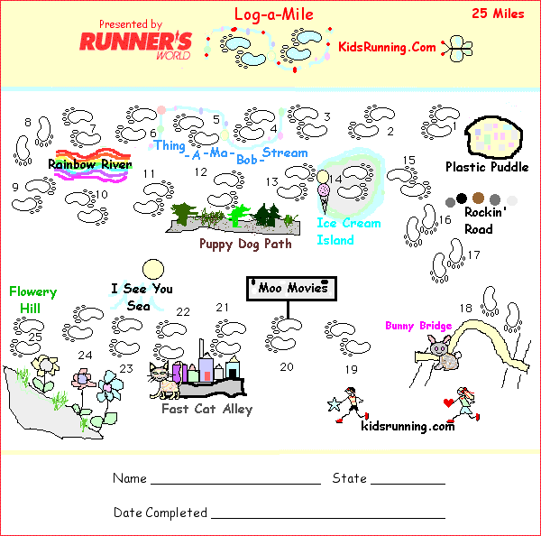

AWARDS
Thing-a-Ma-Bob-Stream:
3 + 3 = 6
Help Mom make some pancake mix (or Dad).

Rainbow River:
4 + 4 = 8
Read a story. Stay up Late

Puppy Dog Path:
6 + 6 = 12
Buy a knick-knack for your shelf.

Ice Cream Island:
7 + 7 = 14
Eat a double dip ice cream.

Rockin' Road:
8 + 8 = 16
Watch a movie you haven't seen.

Bunny Bridge:
9 + 9 = 18
Have some strawberries with cream.

Moo Movies:
10 + 10 = 20
Have some cookies, but not too many.

Fast Cat Alley:
11 + 11 = 22
Pick some flowers, just for you.

I See You Sea:
12 + 12 = 24
Run a mile; only one more.

Now you can still send your chart into KidsRunning and get busy on your next one!
KidsRunning.Com
PO Box 209
Fiskdale, MA 01518

